IT 360 Cloud Integration | Week 3 | Lab 2 (Canvas 3.3)
Docker Containers and a CI/CD Pipeline with Jenkins
Click-by-click Jenkins screens with screenshots, the matching terminal commands, and the verification commands for the Bonneville Brewing menu-board image: build, smoke test, tag with the build number, push with a stored credential that never appears in a log
Course: IT 360-01 Cloud Integration, Ensign College
Instructor: Jackson Isiko, Ph.D.
Canvas: 3.3 Team Lab 2, Docker Containers & CI/CD Pipeline with Jenkins, 40 points. Time: 60 to 90 minutes.
Companion documents: the README in jenkins-docker-pipeline/ (full guide, Docker Hub path, troubleshooting, the GitHub Actions twin) and the Week 3 video in ../gke-helm-networkpolicy/videos/.
Version: 2026-10-29; verified against a live run on 2026-10-31. Jenkins screenshots were taken from a Jenkins 2.541.3 container on the instructor's laptop on 2026-10-29, and every terminal figure is the real output of that run.

How to use this document
Each step has two parts. The Console box tells you where to click in Jenkins, and the screenshot below it shows the same clicks as red numbered boxes. Under every screenshot a What you see paragraph explains the page and each mark. The Terminal block gives the commands that do the same thing, or that prove the result. Do a step one way or the other, not both.
Mac users: before pasting commands into Terminal. The Mac Terminal runs zsh, which does not treat # as a comment when you paste a line, so a line such as ... | grep NODE # note fails with grep: #: No such file or directory. Run setopt interactivecomments once in each new Terminal window and the comments are ignored. Replace every <...> placeholder, angle brackets included, before running a line: zsh and bash both read <word> as "take input from the file word" and fail with no such file or directory. Cloud Shell runs bash and needs only the second rule.
Customize these values to your environment. The instructor run pushes to a private registry container on the laptop (localhost:5005, user brewer) so that no Docker Hub account is needed; it is what scripts/deploy-lab3-2.sh sets up. If you push to Docker Hub instead, your registry is https://index.docker.io/v1/, your image name is <dockerhub-user>/menu-board, and the password is a Docker Hub access token, never your account password. The Jenkins screens are the same either way.
Item | Value used in this guide | Yours
Jenkins | http://localhost:8080, user admin, container jenkins built from jenkins/Dockerfile
Registry | localhost:5005 (private registry container); Docker Hub: https://index.docker.io/v1/
Credential | Kind Username with password, ID `dockerhub-credentials`, username brewer
Image | localhost:5005/bonneville/menu-board; Docker Hub: <user>/menu-board
Job | menu-board, Pipeline script from SCM, branch */main, script path Jenkinsfile
Source | menu-board/ from this folder in a Git repository Jenkins can reach

Watch out
The credential ID in Jenkins must be exactly dockerhub-credentials, because the Jenkinsfile references it by that ID. The token is stored encrypted in Jenkins and printed as ******** in every console log; if you ever see the real token in a log, stop and rotate it.

Part A. Something to build, and Jenkins with Docker access (15 min)

Step 1. The menu-board source and the Jenkins image
menu-board/ holds the site (index.html), the Dockerfile (NGINX Alpine plus the page) and the Jenkinsfile. Push it to a Git repository Jenkins can check out; the script uses a bare repository in a Docker volume so the lab works offline. jenkins/Dockerfile builds Jenkins LTS with the Docker CLI, the Docker Pipeline plugin and a start-up script that creates the admin user, the credential and the job.
Terminal on your laptop (Docker Desktop running)
docker build -t it360-jenkins jenkins/
docker network create brewlab
docker run -d --name jenkins --network brewlab -e SMOKE_NET=brewlab -p 8080:8080 \
-v /var/run/docker.sock:/var/run/docker.sock it360-jenkins
# SMOKE_NET: the smoke-test container is a sibling of Jenkins on the laptop's daemon, reached by name on brewlab
# or everything at once, with a private registry on localhost:5005 and no Docker Hub account:
bash scripts/deploy-lab3-2.sh

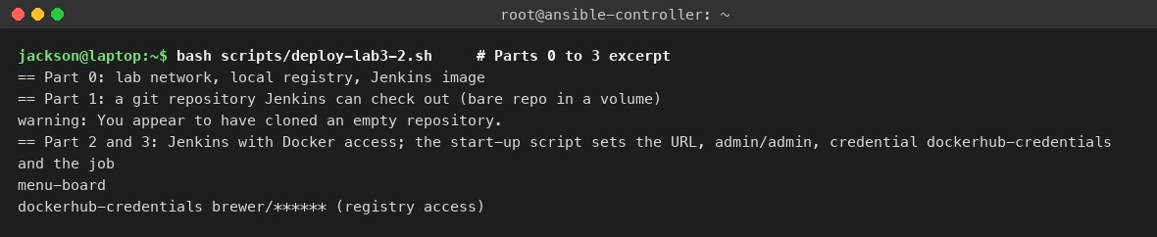
Figure 1. deploy-lab3-2.sh: registry container, Jenkins image, bare Git repository, Jenkins started, job and credential listed.
What you see: The start of the scripted run. Part 0 creates the brewlab Docker network, the registry container with an htpasswd user, and the Jenkins image. Part 1 writes menu-board/ into a bare Git repository in a volume; the git warning You appear to have cloned an empty repository is expected on the first run, because the bare repository is created empty and filled by the same step. Parts 2 and 3 start Jenkins with the Docker socket mounted; the two lines printed by jenkins-cli (the script downloads /tmp/cli.jar into the container first) are the proof that the job menu-board and the credential dockerhub-credentials exist before anyone opened the UI.

Step 2. Sign in
Console: where to click
Open http://localhost:8080. Username (1) admin, Password (2) admin, then Sign in (3). This holds for the scripted install and for the by-hand docker run of Step 1 alike: jenkins/Dockerfile disables the setup wizard and its start-up script creates that account either way.

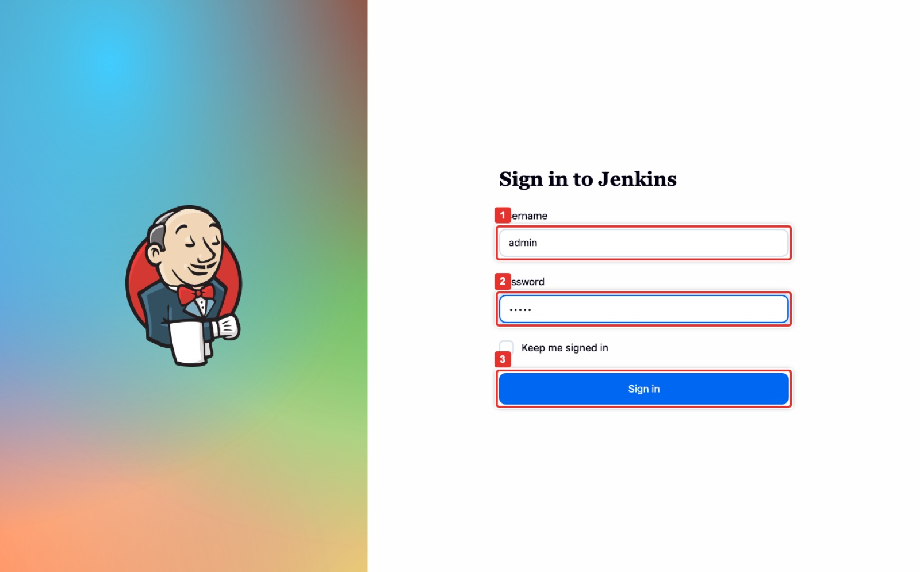
Figure 2. Jenkins sign-in.
What you see: The Jenkins login page. Username (1) and Password (2) are admin / admin because the start-up script of the it360-jenkins image created that account. Only the stock jenkins/jenkins image shows the unlock page and prints an initial password in docker logs jenkins. Sign in (3) leads to the dashboard.
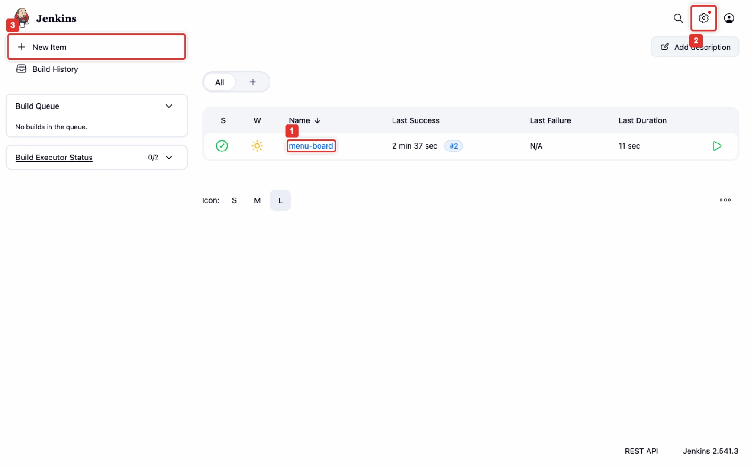
Figure 3. The dashboard: the menu-board job, New Item, and Manage Jenkins.
What you see: The dashboard after sign-in. The job list shows menu-board (1) with its weather icon and last build; on a fresh install the list is empty and you create the job with New Item (3). Manage Jenkins is reached from the gear icon (2) at the top right or the left menu; it holds Credentials and Plugins.

Part B. The credential (10 min)

Step 3. Store the registry token once, by ID
Console: where to click
Manage Jenkins → Credentials → System → Global credentials (unrestricted). The scripted install already lists dockerhub-credentials (1); on your own install click Add Credentials (2).
Kind Username with password. Scope Global. Username (3): your Docker Hub user. Password (4): the Docker Hub access token (Account settings → Personal access tokens, Read and Write). ID (5): dockerhub-credentials. Description: anything. Create (6).

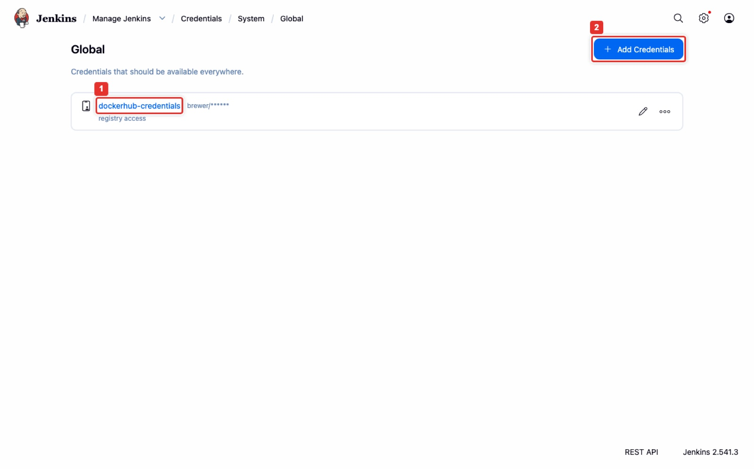
Figure 4. Credentials → System → Global: dockerhub-credentials listed as brewer/******.
What you see: The global credentials domain. The single entry dockerhub-credentials (1) shows the username brewer followed by ******: Jenkins never displays the stored password again. Add Credentials (2) opens the form in the next figure. Jobs reference the entry by its ID, so the token itself never appears in a Jenkinsfile.
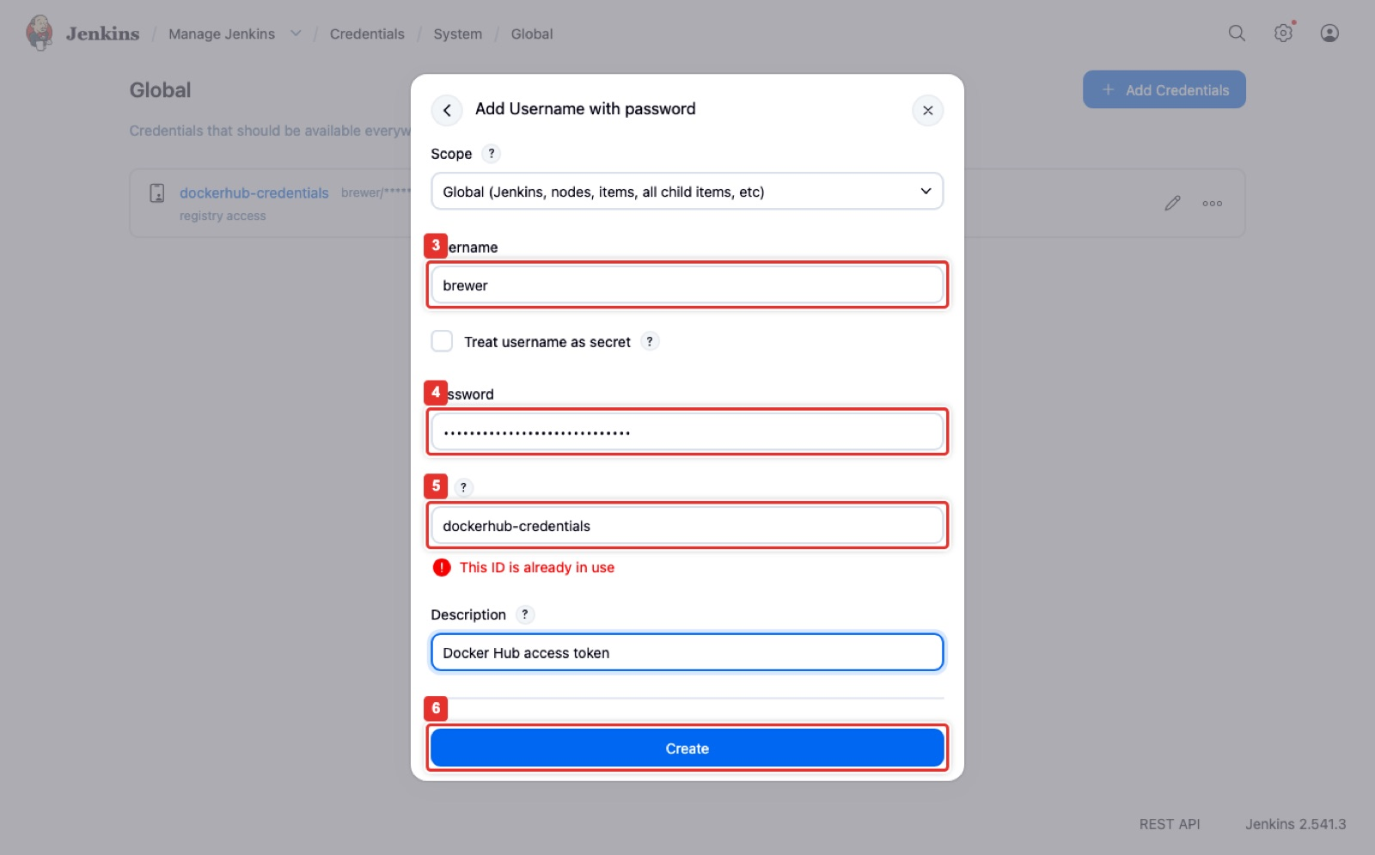
Figure 5. Add Username with password: username, token, ID dockerhub-credentials, Create.
What you see: The Add Credentials dialog with kind Username with password. Username (3) is the registry user, Password (4) is the access token, typed as dots, and ID (5) must be dockerhub-credentials. The red This ID is already in use note appears only because the scripted install created it first; on your own Jenkins the field is accepted. Create (6) saves it, encrypted on disk under /var/jenkins_home.
Expected result
The credential is listed with ****** for the password. Checkpoint: where does the token live now, and who can read it? Encrypted in Jenkins, readable only by jobs that reference the ID.

Part C. The pipeline job (15 min)

Step 4. Create the job from the Jenkinsfile in Git
Console: where to click
New Item → name menu-board → Pipeline → OK. On the job page, Configure (2) opens the form below; Build Now (1) runs it; #2 (3) in Build History opens a build.
In Configure: Definition (1) Pipeline script from SCM, SCM Git, Repository URL (2) your repository (the script uses file:///git/menu-board.git), Branch Specifier */main, Script Path Jenkinsfile (both below the fold of the figure, marks 3 and 4 in the scripted form), then Save (5).

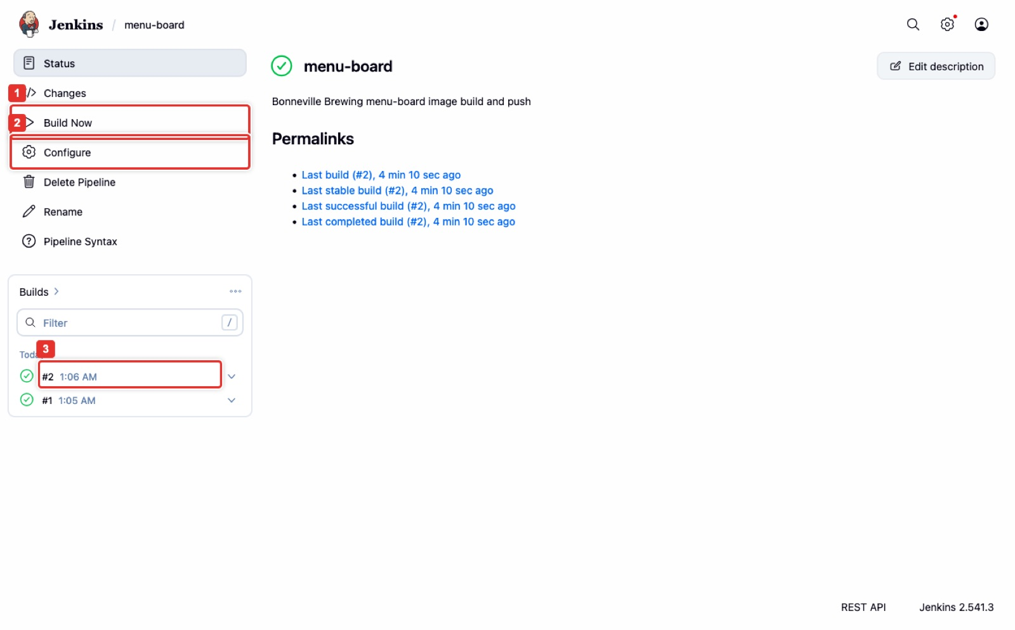
Figure 6. The menu-board job page: Build Now, Configure, Build History with #1 and #2.
What you see: The job page. The left menu has Build Now (1) and Configure (2). Build History on the left lists #2 (3) and #1, both with a green check (success). The middle shows the job description and the Permalinks (last build #2); the four stages Checkout, Build, Smoke test and Push are visible on a build's page and in its Pipeline Steps view (the image has no Stage View plugin). Your job page shows no builds until you click Build Now.
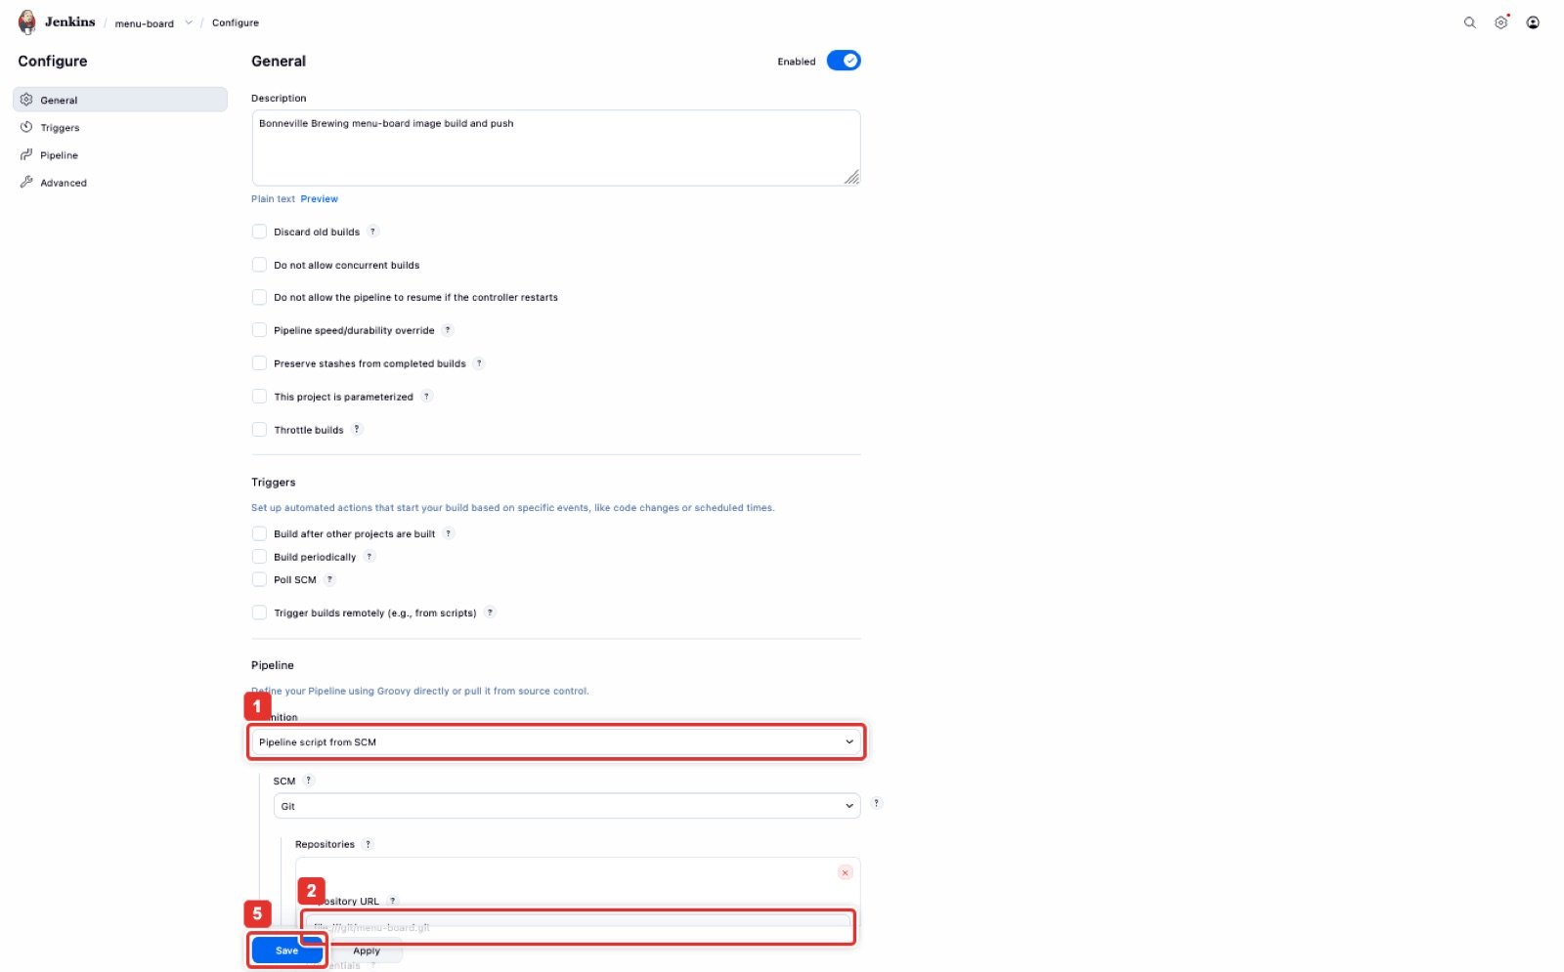
Figure 7. Configure: Pipeline script from SCM, repository URL, Save.
What you see: The Pipeline section of the job configuration, zoomed out so it fits one page. Definition (1) is Pipeline script from SCM, so Jenkins reads the Jenkinsfile from Git instead of from a text box. Repository URL (2) is the bare repository in the volume; yours is the HTTPS URL of your GitHub repository. The form is cut off below the Repository URL: Branch Specifier (*/main) and Script Path (Jenkinsfile) are further down and carry no mark in this figure. Save (5) stores the job. Lightweight checkout stays ticked.
The Jenkinsfile (menu-board/Jenkinsfile, comments trimmed): four stages, the credential referenced by ID; IMAGE_NAME, REGISTRY_URL and SMOKE_NET come from the environment
pipeline {
agent any
environment {
IMAGE_NAME = "${env.IMAGE_NAME ?: 'YOUR_DOCKERHUB_USER/menu-board'}"
REGISTRY = "${env.REGISTRY_URL ?: 'https://index.docker.io/v1/'}"
}
stages {
stage('Checkout') {
steps { checkout scm }
}
stage('Build') {
steps { script { docker.build("${IMAGE_NAME}:${BUILD_NUMBER}") } }
}
stage('Smoke test') {
steps {
script {
def net = env.SMOKE_NET ? "--network ${env.SMOKE_NET}" : ""
def url = env.SMOKE_NET ? "http://smoke-${BUILD_NUMBER}/" : "http://localhost:18080/"
docker.image("${IMAGE_NAME}:${BUILD_NUMBER}").withRun("-p 18080:80 --name smoke-${BUILD_NUMBER} ${net}") { c ->
sh "sleep 2; curl -sf -o /dev/null -w 'HTTP %{http_code}\\n' ${url}"
}
}
}
}
stage('Push') {
steps {
script {
docker.withRegistry(REGISTRY, 'dockerhub-credentials') {
def img = docker.image("${IMAGE_NAME}:${BUILD_NUMBER}")
img.push("${BUILD_NUMBER}")
img.push('latest')
}
}
}
}
}
}

For Docker Hub, set IMAGE_NAME to <dockerhub-user>/menu-board: edit the default on the IMAGE_NAME line, or add it under Manage Jenkins → System → Global properties → Environment variables. When Jenkins itself runs in Docker, SMOKE_NET (set by -e SMOKE_NET=brewlab in Step 1) makes the smoke test start the container on that network as smoke-<build> and fetch http://smoke-<build>/; on a Jenkins VM it stays unset and the test fetches localhost:18080.

Part D. Build, read the log, and prove the secret is masked (15 min)

Step 5. Build Now, then Console Output
Console: where to click
Click Build Now. When the build finishes, open it from Build History and click Console Output. Search the page (Ctrl+F) for your token: it must not be there. Where the credential was used, Jenkins prints ******** (1).

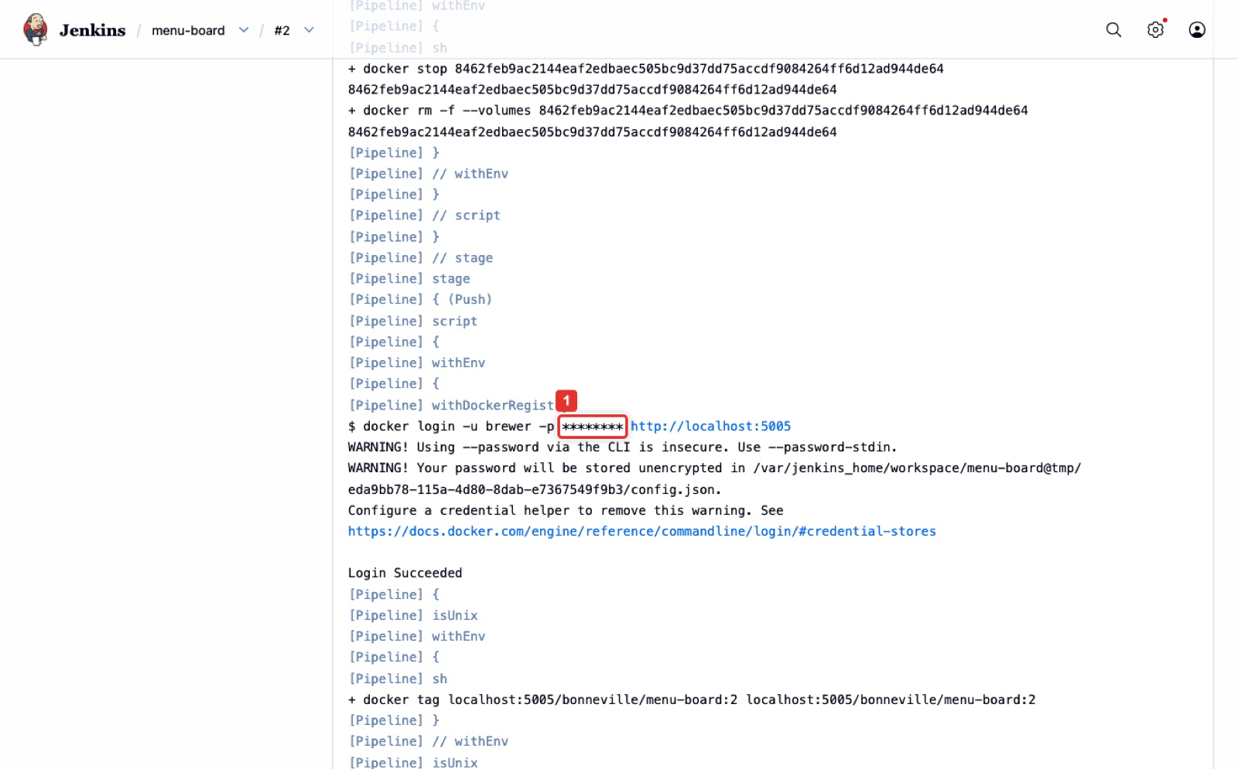
Figure 8. Build #2 Console Output: docker login with the password printed as ********.
What you see: The Console Output of build #2 at the Push stage. The line docker login -u brewer -p ******** (1) is where the stored credential was used; Jenkins replaced the token with asterisks before writing the log, so even the warning about --password on the command line shows nothing. Below it Login Succeeded, then the two pushes. The red box (1) was added for this figure.
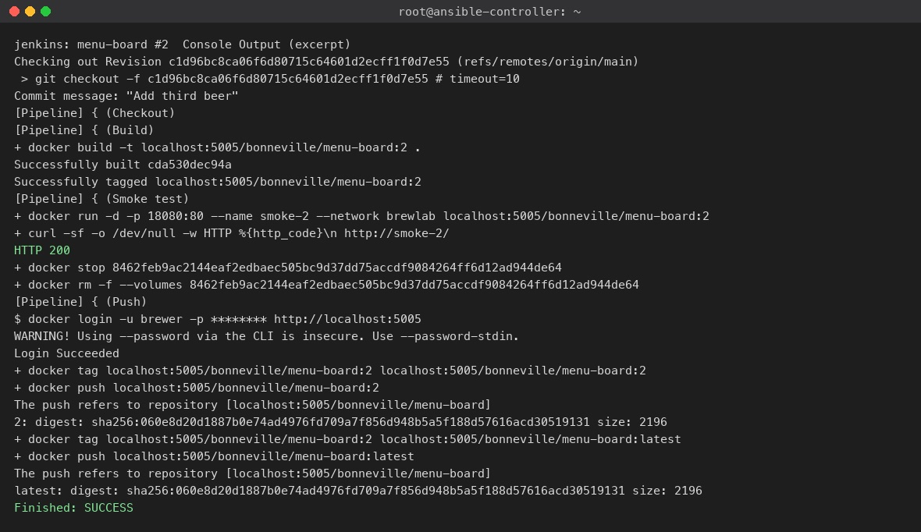
Figure 9. The same log as text: checkout, build, smoke test HTTP 200, masked login, push :2 and :latest, SUCCESS.
What you see: The useful lines of the build #2 console, in order. Checkout reports the commit Add third beer. Build runs docker build and tags the image with the build number. Smoke test starts the image on the lab network, fetches its home page and prints HTTP 200; a non-200 would fail the build before any push. Push logs in with the masked credential and pushes tag 2, then re-tags and pushes latest; both pushes report the same digest because they are the same image. Finished: SUCCESS ends the build.
Expected result
The log shows the build, HTTP 200, two pushed tags, and ******** where the token was used. That is Validation 1.

Step 6. Change the menu, build again, and check the registry
Add a third beer to index.html, commit, push, and click Build Now again. The second build pushes tag 2 and moves latest. Then look at the registry.
Terminal on your laptop (private registry; on Docker Hub open Repositories → menu-board → Tags)
curl -s -u brewer:$REG_PASS http://localhost:5005/v2/bonneville/menu-board/tags/list
docker run --rm -d --name mb2 -p 8081:80 localhost:5005/bonneville/menu-board:2 && sleep 1 && curl -s localhost:8081 | grep -o "<li>.*</li>"
docker stop mb2 # frees port 8081 for Part E; --rm then removes the container

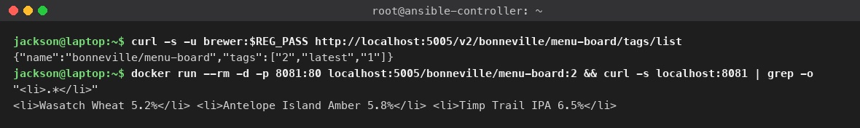
Figure 10. The registry lists tags 1, 2 and latest; running :2 serves three beers.
What you see: The registry's tag list for bonneville/menu-board reads {"name":"bonneville/menu-board","tags":["2","latest","1"]}: the registry does not sort tags, and the set is 1, 2 and latest, exactly one numbered tag per build plus the moving latest. Running tag 2 and fetching the page shows the third beer, Timp Trail IPA, that the second build added. On Docker Hub the same information is the Tags tab of the repository.
Expected result
Tags 1, 2 and latest exist, and latest points at build 2. Checkpoint: a taproom board broke after today's build; which tag do they roll back to? Tag 1, because every build left a numbered tag.

Part E. Verify the pipeline (10 min)
These checks prove the four things the owner asked for: the credential is stored once and referenced by ID, every build is tagged, the smoke test gates the push, and the secret never reaches a log.
Check | Command on the laptop | Expected
Jenkins is up and the job exists | curl -s -u admin:admin http://localhost:8080/api/json | python3 -m json.tool | grep menu-board | the job name
Credential exists, by ID only | docker exec jenkins curl -s -o /tmp/cli.jar http://localhost:8080/jnlpJars/jenkins-cli.jar (the script already did this), then docker exec jenkins java -jar /tmp/cli.jar -s http://localhost:8080/ -auth admin:admin list-credentials system::system::jenkins | dockerhub-credentials listed, no secret
Last build succeeded | curl -s -u admin:admin http://localhost:8080/job/menu-board/lastBuild/api/json | grep -o '"result":"[A-Z]*"' | "result":"SUCCESS"
No secret in any build log | docker exec jenkins grep -rl "$REG_PASS" /var/jenkins_home/jobs/menu-board/builds/ || echo clean | clean
Numbered tags in the registry | curl -s -u brewer:$REG_PASS http://localhost:5005/v2/bonneville/menu-board/tags/list | {"name":"bonneville/menu-board","tags":["2","latest","1"]} (unsorted; the set is 1, 2, latest)
The pushed image runs | docker run --rm -d --name mb-latest -p 8081:80 localhost:5005/bonneville/menu-board:latest; sleep 1; curl -sI localhost:8081 | head -1 | HTTP/1.1 200 OK; leave mb-latest running for the next row, Part F stops it
Rollback works | docker run --rm -d -p 8082:80 localhost:5005/bonneville/menu-board:1; curl -s localhost:8082 | grep -o '<li>' | wc -l | 2 beers (the earlier menu); the same against :8081 prints 3

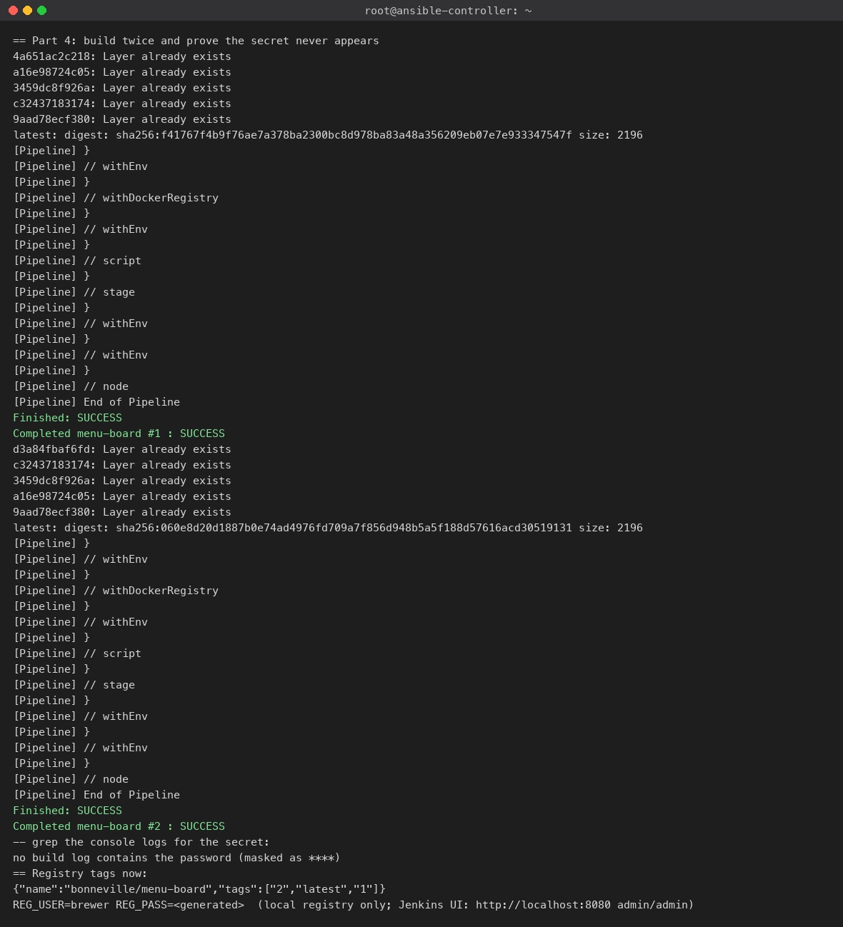
Figure 11. The scripted run's Part 4: two builds, the grep of every build log for the password, and the registry tags.
What you see: The end of the scripted run. The tail of each build's console is printed, ending in Finished: SUCCESS for #1 and #2. The line no build log contains the password (masked as ****) is the result of grepping every build log under /var/jenkins_home for the real registry password. The four asterisks are only that echo's wording in the run pictured; Jenkins itself prints ******** in the console, and the script now prints no build log contains the password (Jenkins prints ******** in its place). The registry then lists tags 2, latest and 1. The generated registry password is shown as <generated> here; the script prints it so you can query the registry yourself.
Note
Docker Hub path: set REGISTRY_HOST=index.docker.io REG_USER=<user> REG_PASS=<access token> before running the script, or create the credential and job by hand as in Parts B and C; the Jenkins screens are identical.

Part F. Clean up
Terminal on your laptop
bash scripts/rollback-lab3-2.sh -y # jenkins and registry containers, containers started from menu-board images, the brewlab-git volume, images, network
# by hand: the two test containers of Part E first, then the rest
docker rm -f mb-latest $(docker ps -q --filter ancestor=localhost:5005/bonneville/menu-board:1)
docker rm -f jenkins registry; docker volume rm brewlab-git; docker network rm brewlab
docker rmi it360-jenkins localhost:5005/bonneville/menu-board:1 localhost:5005/bonneville/menu-board:2 localhost:5005/bonneville/menu-board:latest
# docker image prune would remove only untagged images and leave these tagged ones

Expected result
docker ps -a shows no jenkins or registry container. Docker Hub's free tier is free, so the only thing to clean there is the test repository if you created one.

Part G. What to submit (Canvas 3.3)
- Screenshot 1: the console log with the build, HTTP 200, the two pushes and the masked ********.
- Screenshot 2: the registry tags after build 1 (1, latest). Screenshot 3: the tags after build 2 (1, 2, latest).
- The Jenkinsfile, the Canvas summary, and one line from the quality lead confirming no secret appears in the console log.
- The Team Collaboration and Documentation section.

Appendix. Quick troubleshooting
Symptom | Cause | Fix
docker: command not found in the job | Docker CLI not in the Jenkins image | Use jenkins/Dockerfile, or install docker.io in the container
permission denied ... docker.sock | Jenkins user cannot use the socket | docker exec -u root jenkins chmod 666 /var/run/docker.sock (the container runs as jenkins, so it needs -u root), or add the jenkins user to the docker group on a VM
Push fails with an authentication error | Credential ID mismatch, or an account password instead of a token | ID must be dockerhub-credentials; use an access token
docker.build not found | Docker Pipeline plugin missing | Install docker-workflow
Image not on Docker Hub | IMAGE_NAME differs from the repository name | Match them exactly
Smoke test fails with connection refused | Jenkins runs in Docker without SMOKE_NET, the container is not up after 2 s, or the port is wrong | Start Jenkins with --network brewlab -e SMOKE_NET=brewlab (Step 1); raise the sleep; check the Dockerfile exposes 80
Port 8080 in use on the laptop | Another service | docker run -p 8081:8080 ... and open that port
macOS: registry on port 5000 refuses | AirPlay Receiver holds 5000 | The script uses 5005

Measured time on 2026-10-29: scripted run 3 minutes end to end (image build, Jenkins start, two builds); by hand allow 60 to 90 minutes.

